Data Models in Advanced Mobile Web Application Development

Austin Vanraden

Rasmussen College

Author Note

This project is being submitted on June 6h, 2019, for Darice Corey’s CIS4655C Advanced Mobile Web Application Development course.

Introduction

In this document, we will be going over the various APIs that are most commonly used. The technologies we will be talking about include Web SQL Databases, Indexed Databases, and File Access, which is also used to store data. Each one of these technologies excel at a specific area when it comes to client-side database interactions with web-based applications.

**Web SQL Database.**

Web SQL Database is part of the quite of specifications that allows developers to build web applications that can interact with client-side SQL databases. However, Web SQL Database has been deprecated for quite a few years now. Regardless, some of the browsers still support it because of how tied in it is with SQLite and what it is capable of doing with databases, such as JOINS. However, Web SQL Database limits the developer with creating their own queries in some cases, as you are not allowed to stray away from the existing standards. The Web SQL Database data model looks exactly like what a SQL database would normally look like from what I can tell. I don’t believe there would really be a difference between the two.

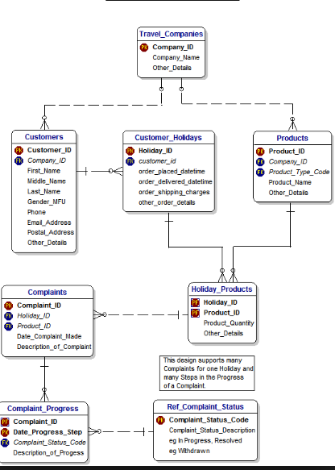

**Indexed Database.**

Indexed Databases provide the same solution that Web SQL Databases would provide, in that they store information on the client’s side. However, there seems to be a significant difference between the two in that Indexed databases are built for performance in a small database. Indexing large amounts of data can depreciate the level of performance the API can provide, so limiting Indexed Databases to smaller tables with lower amounts of stored information would be optimal, while Web SQL Databases would work best with large databases instead. Indexed Databases are also JavaScript-based object-oriented, while Web SQL Databases are SQLite.

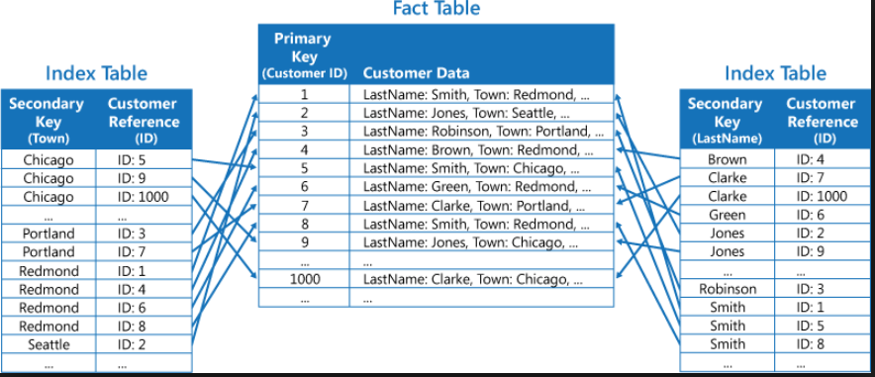

**File Access.**

File Access seems to be an alternative that meets in between Web SQL Database and Indexed Database. Maybe less Web SQL Database and more Indexed Database, but File Access controls access to data in specified tables and columns. Each table and column has its access dictated by an access list. File Access seems to be a solution a client-side instance where many users would have their own data stored on the device.

References

(n.d.). Retrieved from <http://html5doctor.com/introducing-web-sql-databases/>

(n.d.). Retrieved from https://www.ibm.com/support/knowledgecenter/en/SSMLQ4_11.3.0/com.ibm.nex.optimd.install.doc/apxD_Security/opinstall-r-file_access_definition.html

IndexedDB API. (n.d.). Retrieved from <https://developer.mozilla.org/en-US/docs/Web/API/IndexedDB_API>

Kelley, J. K. (n.d.). Why is Web SQL database deprecated? Retrieved from https://softwareengineering.stackexchange.com/questions/220254/why-is-web-sql-database-deprecated